Apparent motion between two frames

Assumes pixel intensities don’t change, neighboring pixels have similar motion

Lucas Kanade method

Involves approximating gradients and time derivatives in 3 by 3 kernels

Works with small movements, error increases with large movements so higher levels of the pyramid are used where as the level increases, resolution decreases and large movements become smaller and easier to work with

Uses cv.calcOpticalFlowPyrLK()

Detect corner points in first frame, then use Lucas Kanade method to track them

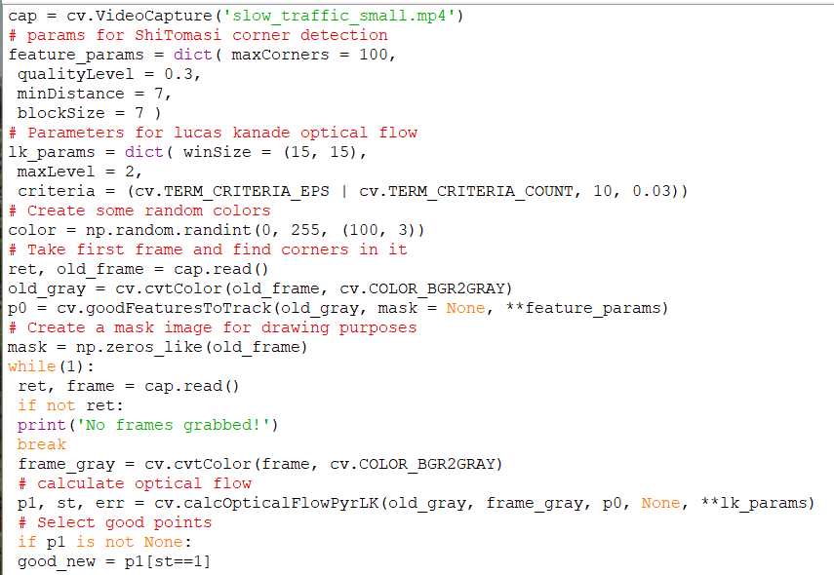

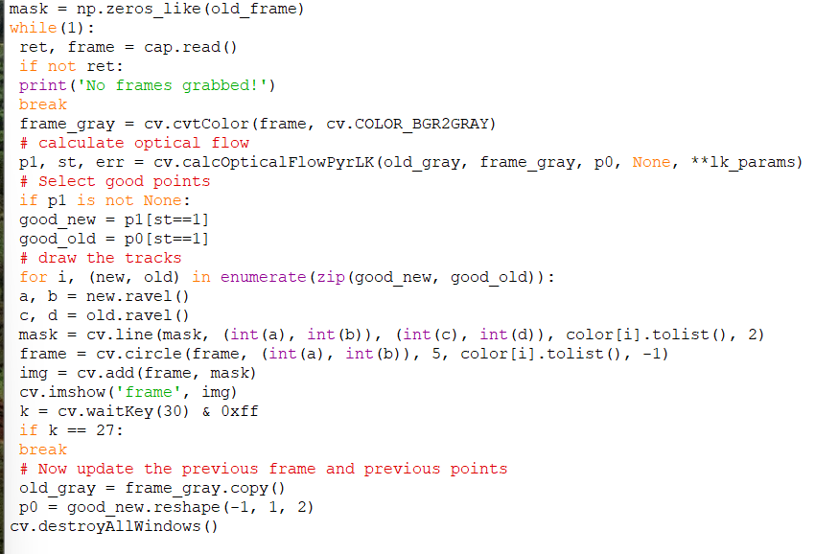

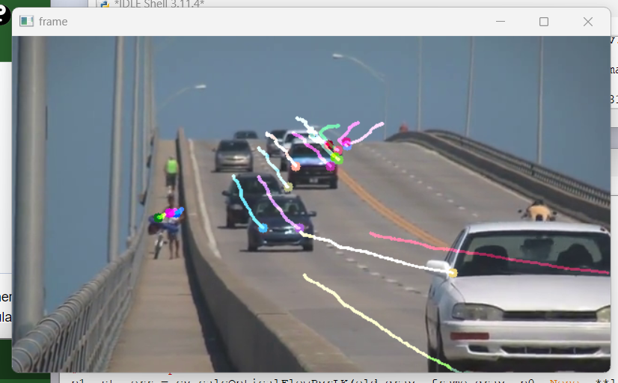

Drawing lines to show optical flow paths

Works on a sparse feature set

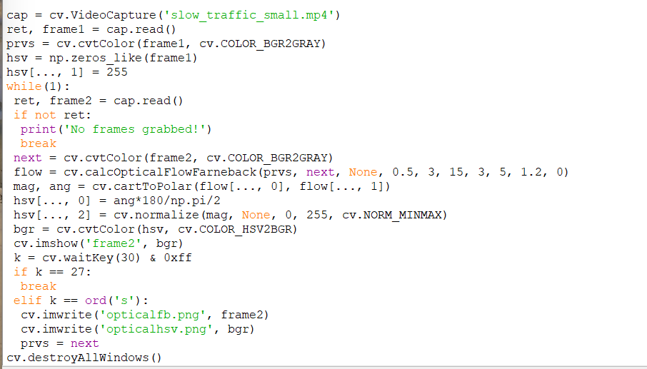

Larger areas with color density represent the Optical Flow vector fields or change in gradient over time

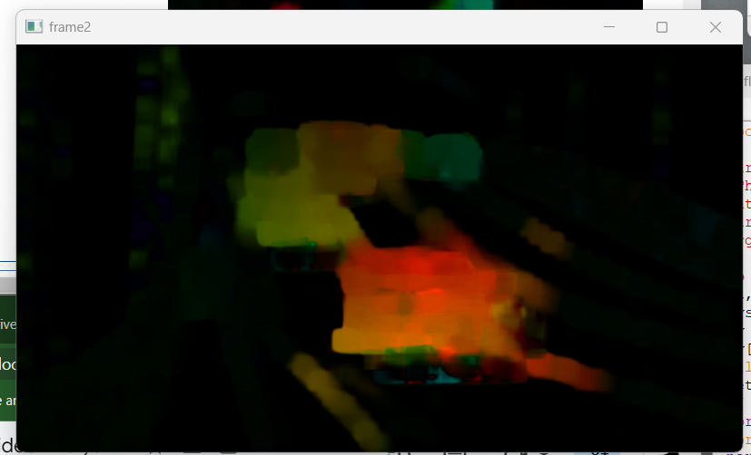

Using same video